

**Haida Child & Family Services Society Newsletter**

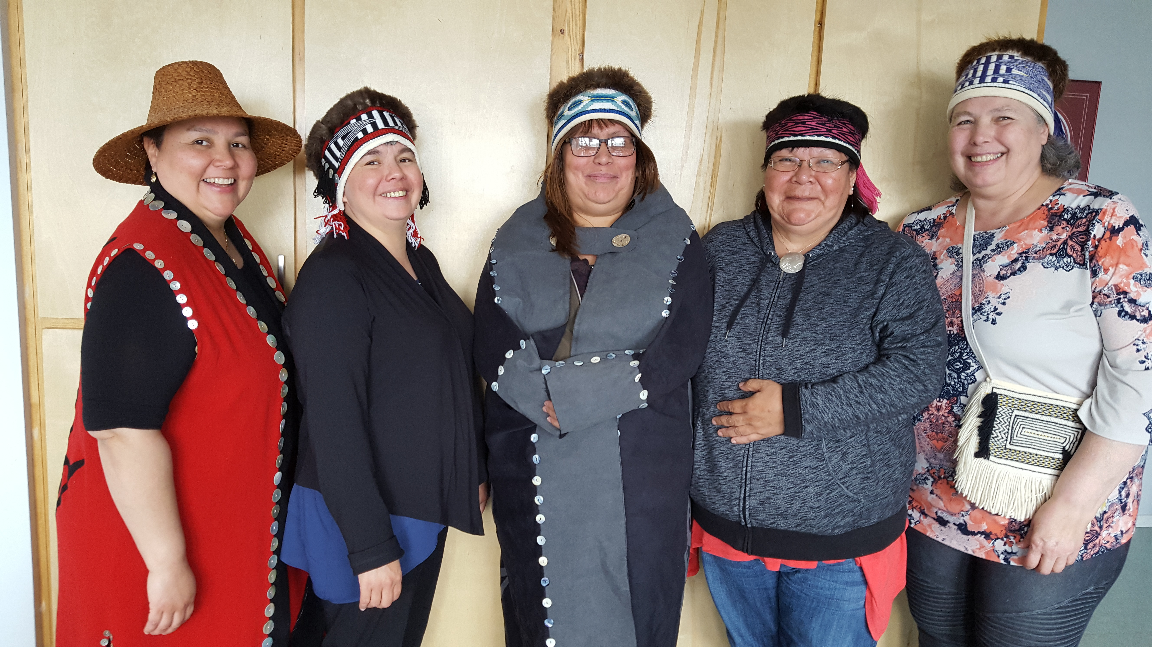

Office Hours & Contact Information:

*Open from:*

*Monday to Friday 8:30 am – 4:30pm*

Please Send All Mail to:

Massett, P.O. Box 86, V0T 1M0

Old Massett Office:

247 Eagle Ave.

P.O. Box 86,

Old Massett, BC, V0T 1M0

Phone: 250-626-5257

Toll Free: 1-888-626-5257

Fax: 250-626-5287

Skidegate Office:

191 “A”, 3rd Ave.

Skidegate, BC, V0T 1S0

Phone: 250-559-8400

Toll Free: 1- 855-559-8400

Fax: 250-559-7746

Website: http://www.hcfss.bc.ca/

Welcome to new staff at Haida Child and family Services Society

Pictured from left to right: *Lisa Bell, Family Support Worker; Tiffany Bell, Administrative Assistant; Maureen Samuels, Family Group Conference Coordinator; File Clerk/Receptionist, Shirley Jones; Karen Wainwright, Executive Director; not in picture Shelley Gladstone, Delegated Generalist Social Worker; Lyndale George, Co-Executive Director, Cleaner at Skidegate Cheryl Pearson; Cleaner at Old Massett Ruby Bell.*

Mission:

“The Haida Child and Family Services Society (HCFSS) are to become self-determining in supporting the children and the families of the Haida Nation. We intend on facilitating and restoring the respect that guided HCFSS relationships and values”.

Vision:

Our Duty: “To create healthy, safe environments for our children and families, by developing and delivering holistic programs and services that model our traditional Haida way of life”.

Values:

Our Values:  “We value what exemplifies our traditional way of life: love, respect, nurturing, caring and sharing”.

Board of Directors

*The 4 Positions of the Executive Committee consist of: 1 Chair, 1 Vice Chair, 1 Treasurer, and 1 Secretary.*

The B.O.D. are represented by:

*1 Member of the Council of the Haida Nation*

*1 Hereditary Chief, Old Massett*

*1 Hereditary Chief, Skidegate*

*1 Member of the Old Massett Village Council*

*1 Member of the Skidegate Band Council*

*1 community representative from Skidegate*

*1 community representative from Old Massett*

*2 Alternate Hereditary Chiefs*

Community Engagement and Evaluation Public meetings where held in Old Massett and Skidegate.

In October 2016 Lyndale George, co-executive director at Haida Child & Family Services Society, contracted Dana Moraes, Community planning Facilitator, to conduct Community Engagement Sessions and Evaluations for Haida Child and Family Services Society. Together they created a process for the session: including agendas handouts and common presentation materials. Door Prizes and meals are provided at the Engagement Sessions. The “Haida Café” style session took place in Old Massett and Skidegate. There were 2 sessions before winter and 2 in the spring. They were well attended.

During the session there are three forms of engagement: 1) evaluation through a survey 2) a presentation by Lyndale George, Co-Executive Director who reviewed the HCFSS’s vision, mission, goals and introduction of staff and programs 3) The “Haida Café” where all participants receive question topics to brain storm and give their written feedback to the group. Next steps for HCFSS are recommended by the Board of Directors from the results of the Evaluation. The end goal is to use the information gathered from the community to further develop HCFSS Strategic planning. There will be four more sessions. Watch for the posters on your local Community Announcement Board.

Haida Child and Family Services Society: Agency History

**1991** – Sparked by the Provincial review of child protection legislation in 1991, Skidegate and Old Massett began discussions around the development of a Haida Child Welfare authority.

**1992** – A pre-planning report was submitted by Ruth Gladstone-Davies

**2002** – During the summer, both the Village Council of Old Massett and the Skidegate Band Council passed Band Council Resolutions supporting the development of a child welfare authority and requested funding from Indigenous and Northern Affairs Canada (INAC) (formerly Aboriginal Affairs and Northern Development, AANDC) through Directive 20-1 enabling further pre-planning and planning to take place.

A consultant was hired to do the pre-planning.

In late summer, the planning group met with Northwest Inter-Nation staff and board of directors to explore the option of joining their society.

**2004** – In July, a Child Welfare Advisor was hired to assist with the planning process.

A comprehensive work plan was developed in July outlining all the required steps for the development of an agency.

In November, a Haida person with a background in social work was hired to work with the child welfare advisor and to assist with the community consultation process.

In December, a meeting was held with Haida leaders to explore governance options for the agency. A stand alone, non-profit society model was chosen as the preferred option.

**2005** – In January and February, several community sharing meetings took place in Skidegate and Old Massett.

During the months of January, February, and March, a comprehensive needs assessment was completed in both Haida communities. The needs assessment indicated strong support for a Haida child and family services agency, as well as identifying a need for more community services, particularly for youth.

Negotiations with the Federal and Provincial governments began on June 28th.

Haida Child and Family Services Society (HCFSS) became a duly constituted not-for-profit society on **December 16th, 2005**.

**2006** – A *Delegation Enabling Agreement* was signed in March.

HCFSS hosted 2 Homecoming Events

**2007** Strategic planning was completed by past Board of Directors (BOD) and Staff.

In this time period there had been several changes in management, programs and funding.

The BOD was restructured and funding for the Board was given a cap.

**2013** – HCFSS BOD employed two Co-Executive Directors: one supervised and continues to supervise (now as Executive Director) the delegated work and operates out of the Old Massett Office. The other Co-Executive Director was and still is the Operations Manager, supervised and continues to supervise non-delegated employees and operates out of the Skidegate Office.

Unfortunately, due to funding cuts and other logistical issues, a number of programs were ended, and some staff members were laid off.

The non-delegated support programs were restructured and rebuilt, the Family Support Program was restructured into the Family Support Worker (FSW) program and a Family Group Conference Coordinator (FGCC) program.

**2015** – HCFSS has signed yearly *Delegation Enabling Modification Agreements* up to March 31, 2016.

In November a new Analysis Document Called, “*Haida Workload and Resources Balancing Assessment Analysis for Delegated Aboriginal Child & Family Services*”, was completed by Ministry of Children and Family Development to determine if HCFSS was able to move forward to Category 3 (C-3) Delegation under the “*Delegation of Authority to Aboriginal Agencies*" Matrix.

HCFSS completed the *C-3 Operational Review Compliance Tasks* in December.

HCFSS began investigating the feasibility of moving under the umbrella of the Council of the Haida Nation.

**2016** – Current; HCFSS has completed Strategic Planning with BOD members and staff.

The HCFSS Work Plan included recommendations from MCFD’s new Analysis Document. MCFD and Indigenous and Northern Affairs support the plan.

HCFSS is now taking practicum students who are doing social work programs.

HCFSS is rebuilding staff and will be training staff in order to move HCFSS to the C-3 & C-4 Delegation. This will result in Foster Parent and Guardianship files being transferred from MCFD to HCFSS.

***If you know of a child or youth that might be in Danger, Please Report to th****e* **Ministry of Children and Family Development Centralized Screening: 1-800-663-9122**

**If you or someone you know is/are interested in becoming foster parents please call our office or the Ministry office at:** **250-559-4403.**