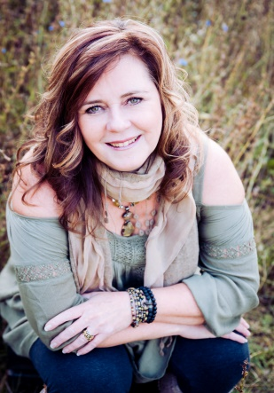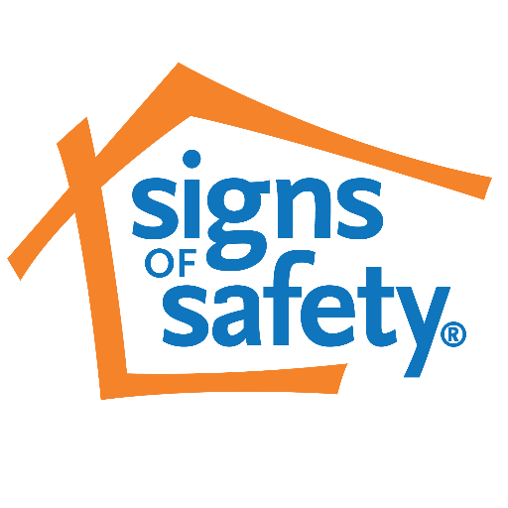

CAARA GODDARD CONSULTING

**Register by telephone or email. Deadline for registration is September 18, 2017.**

**Morning and afternoon snacks**

**will be provided.**

**Lunch will be catered.**

**Door Prizes**

Hosted by

Haida Child & Family Services Society

This training will take place in the

Tluu Xadaa Naay Long House

[Christian Whites Longhouse]

please contact

Shirley for more information fileclerk.reception@hcfss.bc.ca

Or 250-626-5257

***Haida Child & Family Services***



Join Caara Goddard for a three day introduction and overview of the Signs of Safety Framework. This training will help workers become familiar with using the core assessment tools to clearly identify risks in a strengths-based, child-centered way. We will work to identify clear next steps to shift current practice by identifying and building on cultural and family strengths that already exist. Integrating community strengths in leadership contexts is critical to evolve this practice shift.

Caara Goddard, MSW—Licensed SoS Trainer & Consultant

Introductory Three Day Training. Sept 25th—27th. 9am-4pm

Signs of safety